**North South University**

**Department of Electrical & Computer Engineering**

**Junior Project Report**

**Spring 2020**

**Title of the Project:** Doctor and Patient management system.

**Group: 04**

**Names and IDs of the students:**

|  |  |
| --- | --- |
| **Name** | **Id** |
| **Md Sharif Hossain** | **1712336642** |
| **Rubaida Ferdous** | **1711126642** |

**Faculty’s Name: Intisar Tahmid Naheen (ITN)**

**Date: 4th June, 2020**

Table of Contents

Abstract: 4

Keywords: 4

Introduction and Background: 5

Objectives: 5

Scope: 5

Methodology and Approach: 6

Used Software and views: 6

User Interfaces: 6

Hardware Interfaces: 10

Software Interfaces: 10

Database: 10

Communications Interfaces: 11

Budget: 11

Time Plan: 12

Used Platform: 12

i. Course communication in Piazza 12

i. Group Communication in Slack 13

ii. Project sharing repository in GitHub 13

iii. Tracking weekly activities in Trello board 14

Expected Outcomes: 14

Discussion: 14

# Abstract:

This is a web-based management system where registered doctors can prescribe their treatments and patients can have their prescriptions at the same time.

The system can be used for controlling banned and unregistered medicines, registered doctor ensuring, printed prescription even without having a printer in doctor’s room, storing people’s medical documents lest it’s lost, analysing and research advantages on people’s diseases and treatment process, providing free online health guide, central blood bank, 24/7 medicine home delivery, authentic financial fundraising, common communication platform among doctors and many more.

**Keywords:** Printed prescription, control over banned medicines, research advantage, online health guide, blood bank, communication.

# Introduction and Background:

This is a web-based management system where there will be a patient’s and doctor’s ID(s). Registered doctors can prescribe for a patient and it will be stored in the patient’s ID. No unregistered doctors can prescribe a patient and no doctor can prescribe anything out of a licensed medicine list.

In some hospitals, there is usage of the online system but in general there is no existence of such service.

# Objectives:

The objectives of this project/thesis are to…...

1. Ensuring registered doctors for each patient
2. Banning the unlicensed medicines
3. Ensuring digital printed prescriptions for the patients.
4. Storing people’s medical history for later use and research
5. Providing free online health guide
6. Central blood bank
7. 24/7 medicine home delivery
8. Authentic financial fundraising
9. Common communication platform among doctors etc.

# Scope:

Following tasks were meant to be undertaken as a part of the project:

Task 1: Making a demo system.

Task 2: Research on its acceptance on the market.

Task 3: Taking people’s opinions and making it better etc.

# Methodology and Approach:

# There is a list of all registered doctors from administration. Doctor’s ID will be created from admin.

# Patients can sign in their accounts. Their password will be encrypted and saved in the database.

# No doctors can give prescription without an account from the administration.

# Doctors cannot prescribe medicines out of the database connected to the system.

# All medical history of a patient will be recorded so that one can find any history whenever s/he needs that.

# Used Software and views:

## **User Interfaces:**

1. There is a user-friendly homepage for all common users.

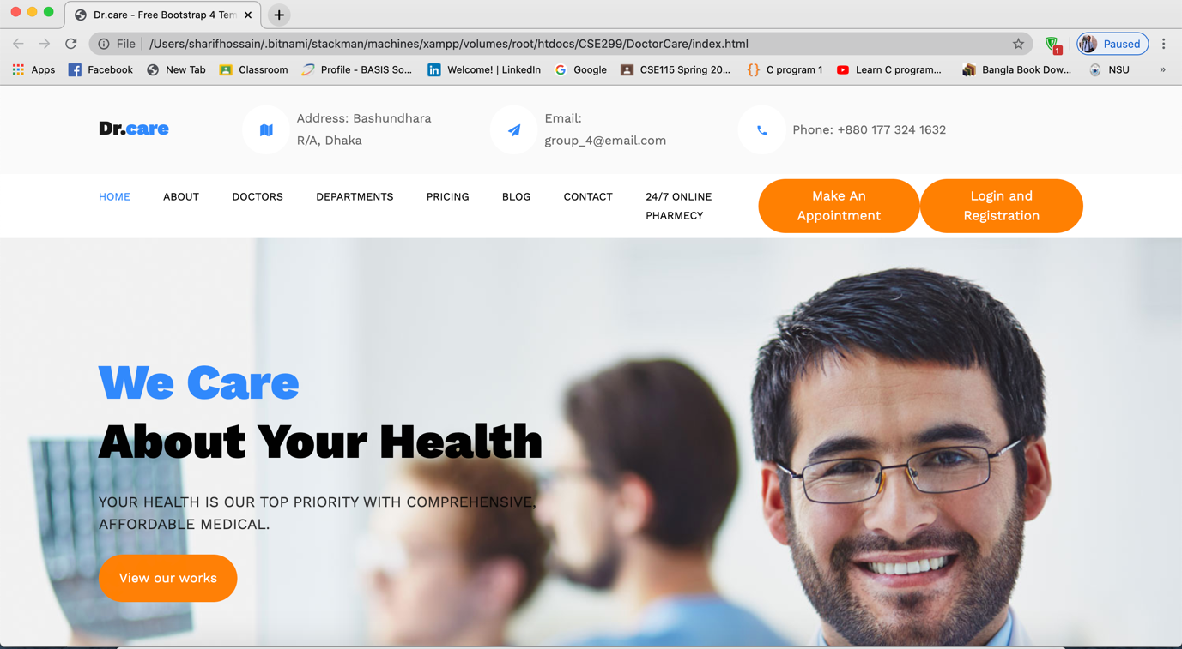

**Figure 1:** Homepage

1. Users have a login and registration page. Patients must be registered before login. Anyone can register or sign up by providing a unique user name, email, and a password. The password will be encrypted and saved in the database.

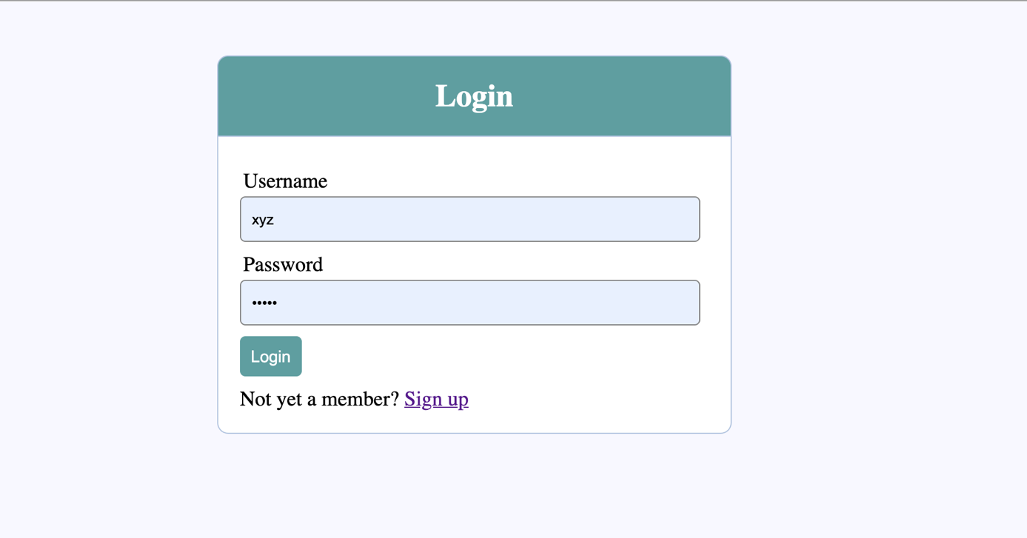

**Figure 2:** Login page

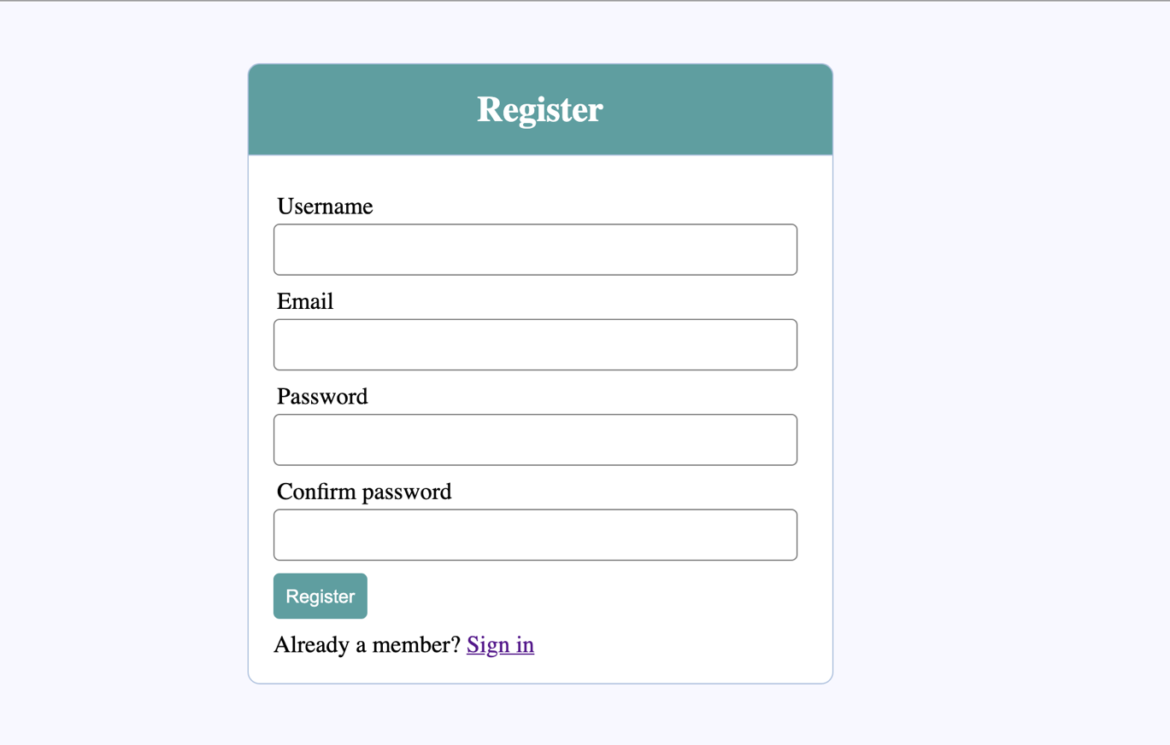

**Figure 3:** Registration page

1. Users will find a dashboard after login.

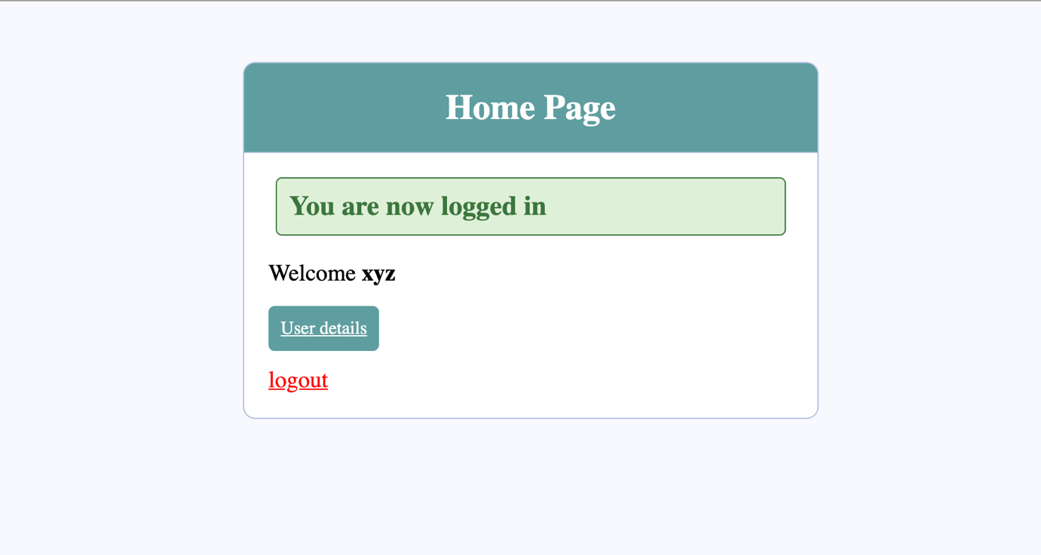

**Figure 4:** User dashboard

1. Users can find their activity page inside “User details”

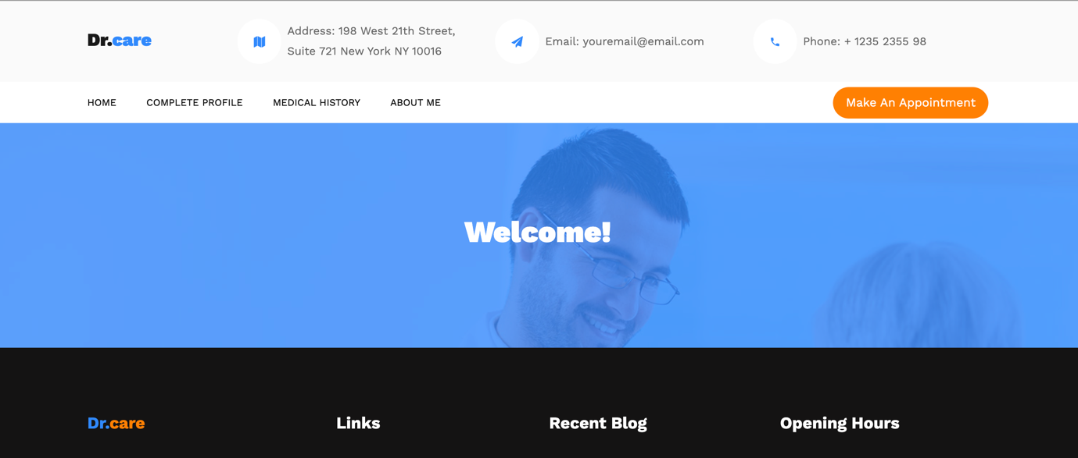

**Figure 5:** User activity page

1. Users can update their additional information in the “Complete Profile” and view it in the “About me” option. 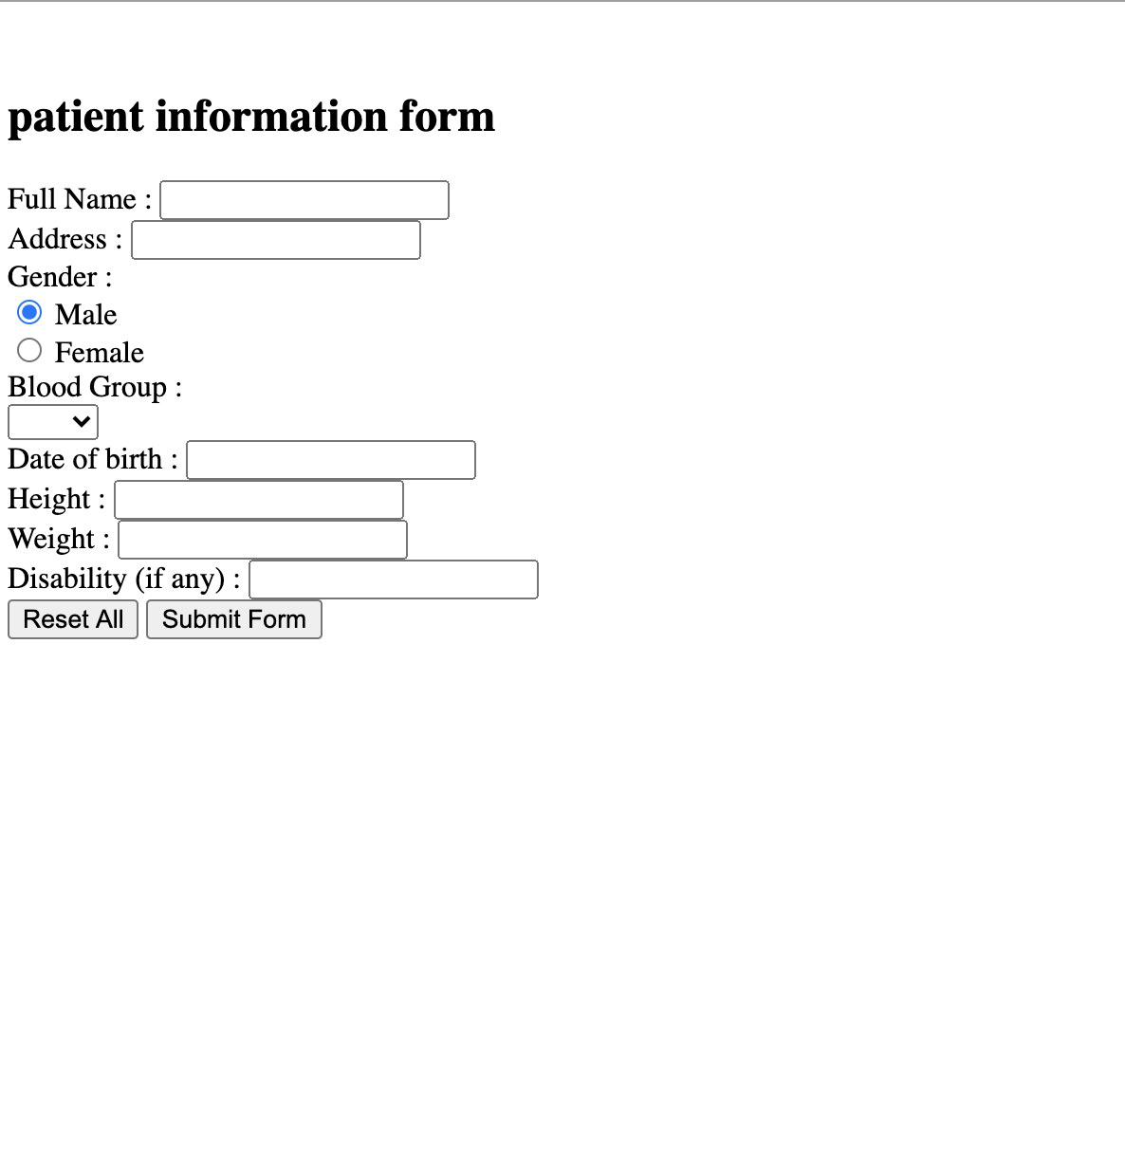

**Figure 6:** Complete profile form

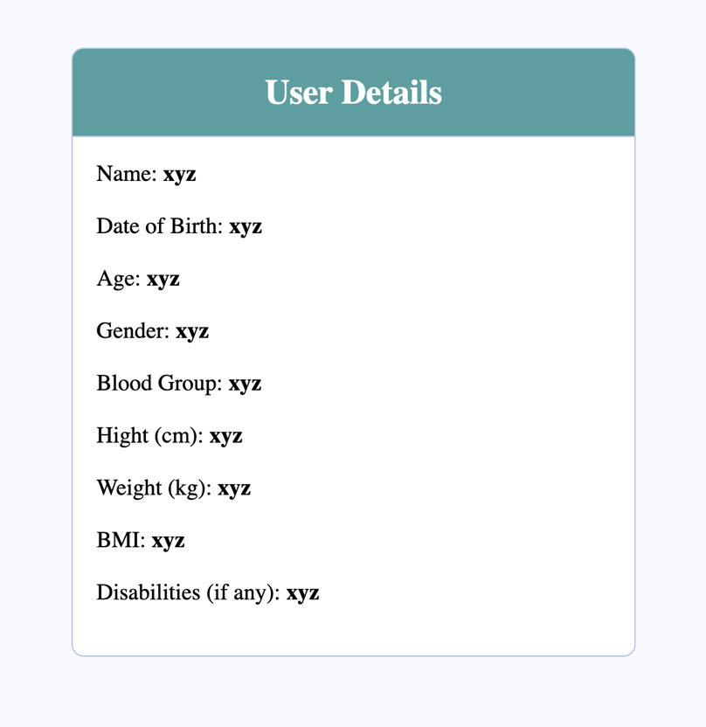

**Figure 7:** User Details

1. Doctors are registered from admin. They will use a pre-registered User ID and password.

## **Hardware Interfaces:**

* Windows or Linux
* Browser (Support JavaScript, CGI, Html)

## **Software Interfaces:**

Html, PHP is used for the website. The server will be created using JavaScript. User Information like username and password is shared between the database and the server. The patient’s records are also shared between the database and the server. A doctor can see any patient's report while logged in.

## **Database:**

The database is created using MySQL on the Apache server.

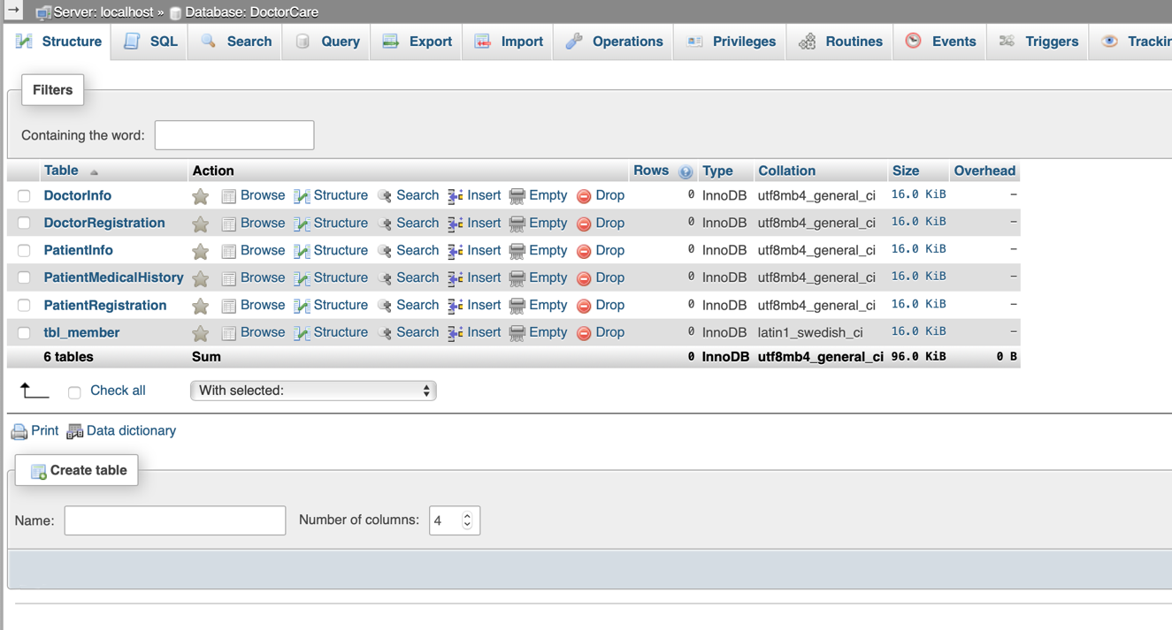

**Figure 8:** Database tables

User id and email are saved according to inputs and password is stored after encryption.

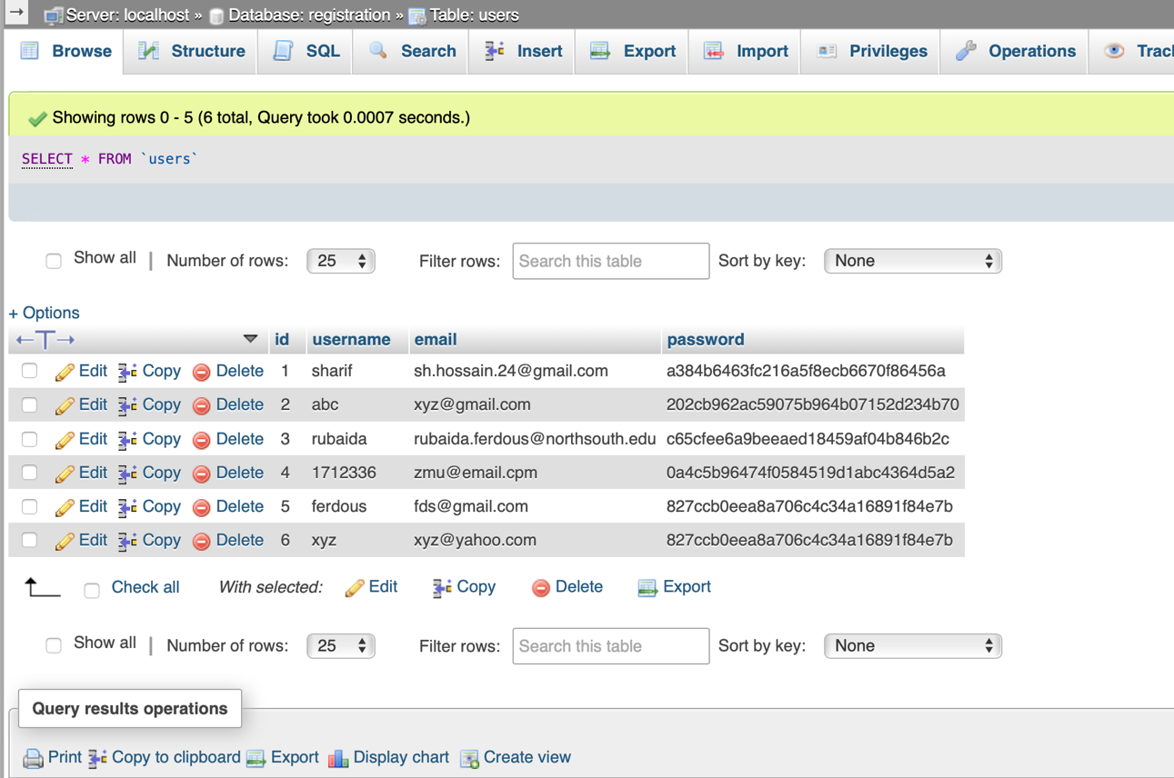

**Figure 9:** Login table and registration data

## **Communications Interfaces:**

* This project supports all types of web browsers which support Html 5 and JavaScript.
* We will be used Apache for server and MySQL will be used for the database.

# Budget:

# As it is a web-based software system, initially no specific budget is applicable for the application. It was created by using all free sources.

# Time Plan:

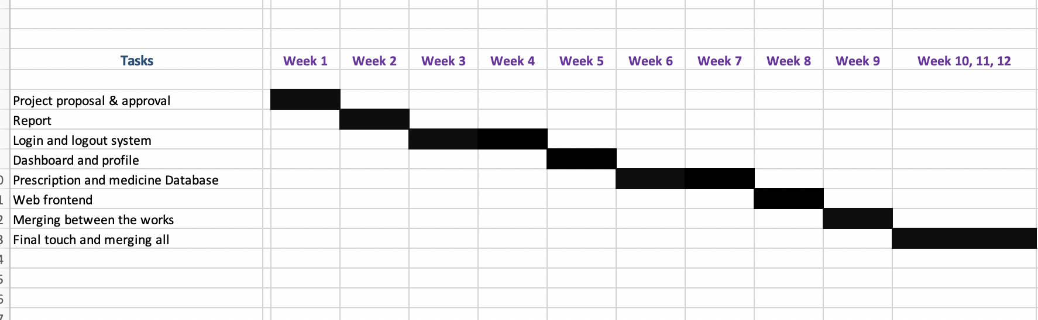

**Figure 10:** Gantt chart

# Used Platform:

## **Course communication in Piazza**

A class in Piazza was used as a common platform for entire course communication and sharing weekly updates.

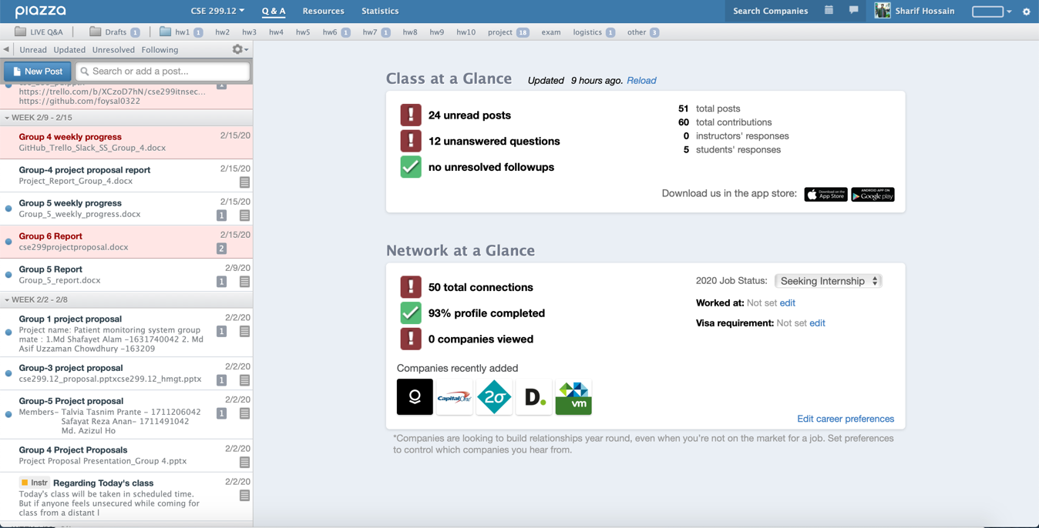

**Figure 11:** Updates in Piazza

## **Group Communication in Slack**

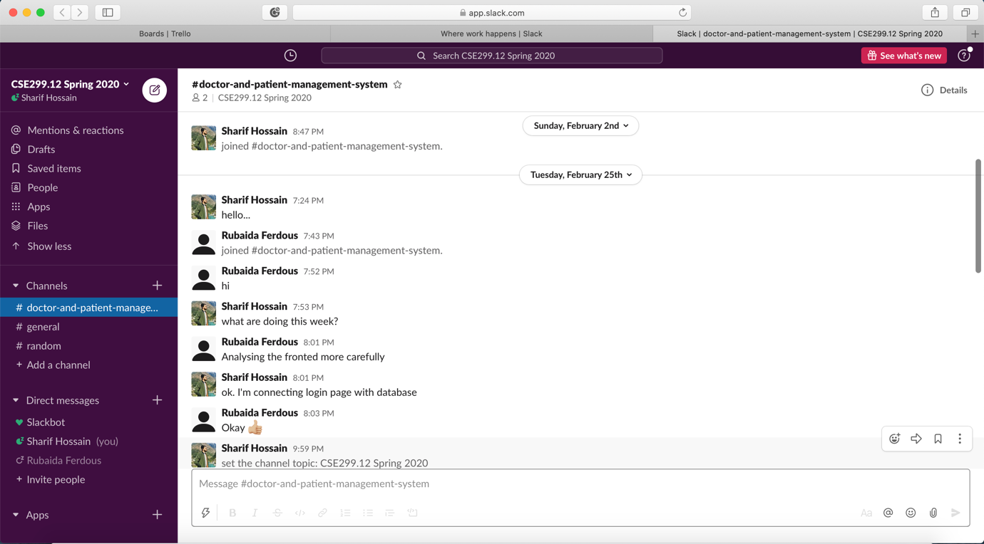

**Figure 12:** Communicating in slack among groupmates

## **Project sharing repository in GitHub**

## 

**Figure 13:** GitHub repository

## **Tracking weekly activities in Trello board**

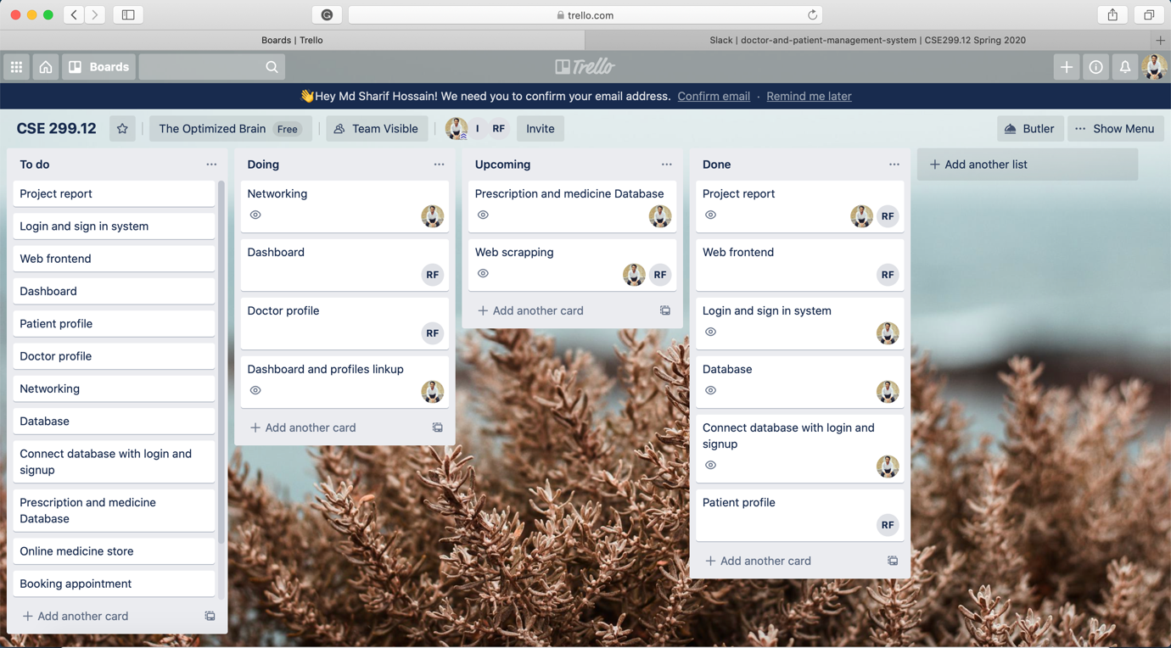

**Figure 14:** Trello Board

# Expected Outcomes:

At the end of the semester, it was hoped to build a stable platform which could be used as a demo of the offered project.

# Discussion:

Updates of the first six weeks were almost according to the time plan. Unfortunately, after the outbreak of the Covid-19 Corona Virus and lockdowns, further updates couldn’t be made. In the circumstances, it is requested to consider the project accordingly.